Event Budget Performance Tool Project Documentation

Requirements of the Tool
1. What the tool must do
Entering information
- Let the user add an event with: event name, category (catering, venue, security, transport etc.), date, planned budget, actual cost, income (if any), expected attendees and actual attendees. (Your choice; the brief says to use budgets, costs, income and attendance.)
- Let the user edit or delete an event they’ve added.
Calculating
- Work out for each event: (Brief: “useful calculations”)
  - Variance: actual cost minus budget, so you can see if it’s over or under
  - Variance %: how far over or under, as a percentage
  - Cost per attendee
  - Attendance rate: actual guests as a % of expected
- Show overall totals: total budget, total spent, money remaining, and how many events are over budget.
- Flag problems clearly, for example red for over budget and green for within budget.
Exporting data
- Have a button that downloads all entered events as a CSV file that opens in Excel and Power BI. (Brief: “generate data that can be analysed in Power BI”)
2. How the tool must behave
- It works entirely in the browser. It uses HTML, CSS and JavaScript only, with no server, database or login. (Brief, must)
- It checks input. It stops the user entering blank names, negative money or letters in number fields, and shows a helpful message. (Your choice; good for your testing evidence)
- It follows Commonwealth branding: their colours, fonts and logo rules. (Brief, must)
- It’s easy to use for non-technical staff, with clear labels and simple layout.
- It works on different screen sizes and in common browsers (Chrome, Edge). (Your choice)
- It’s clearly labelled as a prototype, for example with a banner saying “Learning prototype – sample data only”. (Brief: must not look like a real system)
3. Data requirements
- Use fictional data only. No real names, people or confidential figures. (Brief, must)
- Keep the data tidy for Power BI: one row per event, the same columns every time, numbers stored as plain numbers (no £ signs inside the values) and dates in one consistent format. (Brief: “well-structured”)
4. Dashboard requirements
- Load the CSV exported from the website. (Brief)
- Show 3 to 5 clear insights, for example (Brief: “a small number”):
  - budget vs actual spend per event
  - spending by category
  - headline totals and the percentage of budget used
  - cost per attendee
5. Project requirements (around the tool)
- GitHub: private repository, sensible name and description, README added, no template, no .gitignore, no licence. (Brief, must)
- Markdown documents:
  - your requirements (this list)
  - assumptions and limitations
  - a user guide
  - technical notes
  - a test record
(Brief, must)
- Publish with GitHub Pages, but only after your supervisor approves. (Brief, must)
- Demo the finished work and reflect on what you learned. (Brief, must)
6. Assumptions
- All money is in GBP (£).
- One user at a time, on one computer. Nothing is shared or saved online.
- Data is for demonstration only and isn’t accurate to the real CHOGM.
7. Priorities (what to build first)
Priority
Must have | Add events, calculations, totals, CSV download, branding, front-end only
Should have | Input checking, over/under-budget colours, sample data button
Could have | Edit or delete events, filters, extra charts on the website itself

What information does the website need to collect

What the user types | Example
Event name | State Banquet
Category | Catering
Date | 2026-11-12
Budget (£) | 50000
Actual cost (£) | 56000
Income (£) | 0
Expected guests | 200
Actual guests | 180

The website will then work out these itself, so nobody has to type them:
- Overspend or underspend (£ and %)
- Over or within budget
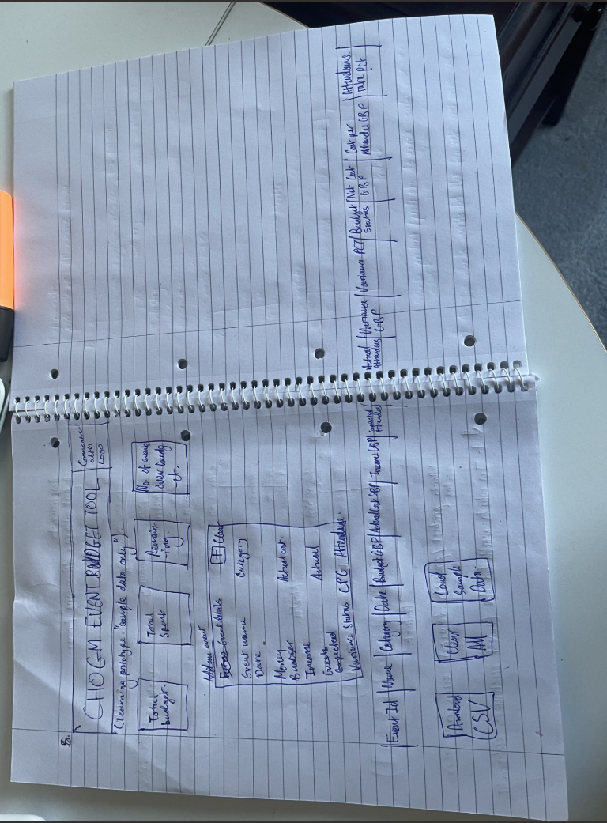
- Cost per guest
- Attendance %

Wireframe

Entry log for Documentation
19/10/2026
Today I looked into the task requirements and made sure I fully understood the briefing task provided to me. I then went ahead and built the requirements for the tool, including what information the website needs to collect. I finally designed the wireframe to close off the day.

